**Cloning the Repo**

1. Install git
   1. First check to make sure you don’t already have git installed by opening the terminal/windows powershell and using the command “git –version”
   2. This is how it will look if you already have it installed.
      1. A black screen with white text

         Description automatically generated
      2. If given a version you can proceed to step 2.
   3. If not, then go to <https://git-scm.com/download/win> and download the installer.
   4. Once installed, you should be able to run the command in step 1b to see your git version.
2. Navigate to the umgc/fall2024 repo
   1. A screenshot of a computer

      Description automatically generated
3. Click the green code button
   1. 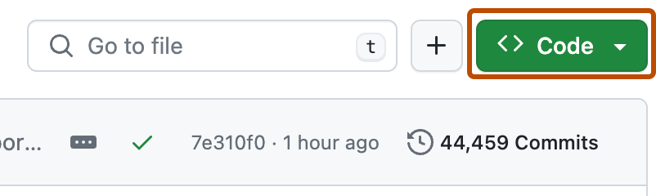
4. Ensure HTTPS is selected and click the copy to clipboard button
   1. A screenshot of a computer

      Description automatically generated
5. Go back to the terminal/shell and navigate to the folder in which you want to clone the repo.
6. Enter the command “git clone <Copied URL>”
   1. A screenshot of a computer screen

      Description automatically generated
7. You should see all of the files now in your file explorer.

**Switching to the teamB branch**

1. After successfully cloning the repo return to the terminal/PowerShell and navigate to the repo folder.
2. Use the command “git checkout teamB” to switch to the branch with our project files.
   1. A screenshot of a computer program

      Description automatically generated
3. Use “git pull” to pull the branch files to your computer
   1. 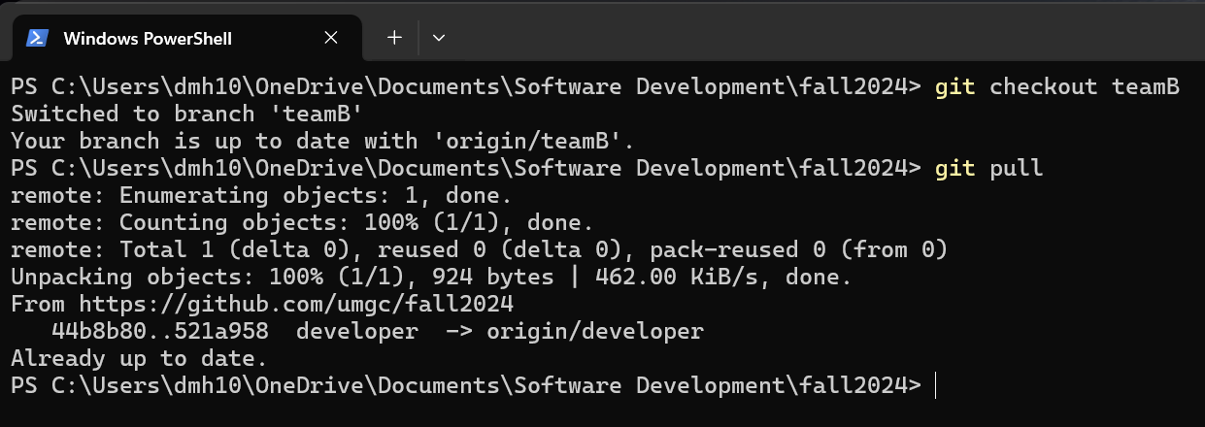

**Normal Git Workflow**

1. When you sit down to start working on the project you usually always want to start by doing a “git pull” to get the latest updates for your branch.
2. Once you have completed your current work session you will use the “add”, “commit”, and “push” commands.
3. “git add -A” - adds all of the changes you have made on your local files to the staging area so that they can be committed.
   1. If there are any errors git is usually pretty good at telling you what the error is and what you should do next.
   2. Some professionals frown on using the “-A” for all files and instead add each file individually as you complete them, but this is the easiest way.
4. “git commit -m”Message Here”” – this command commits the changes that you added in the previous step to be pushed once you enter the push command.
   1. You must the “-m” with a message in quotation marks otherwise it will open the commit in vim and expect you to type the message there. If you find yourself in that situation just follow these steps:
      1. Press the “esc” key
      2. Type “ctrl + q” to quit
      3. Redo the commit command with the message.
   2. The message can be anything you want but you should usually try to give a very brief statement about what you did in the commit.
      1. i.e. “did work on X feature”, “completed x feature”, “fixed a bug that caused x issue”
   3. A screen shot of a computer

      Description automatically generated
5. “git push” -pushes your committed changes to the GitHub repo for everyone to see and pull.
   1. A screenshot of a computer program

      Description automatically generated

**Tips**

1. Use “git status” to get an idea for what you need to do next.
2. If you get an error message READ it. Like I said earlier, git is really good at telling you what you need to do to fix an issue. It took me longer than I want to admit to figure this out.
3. If you still can't figure it out, reach out on the teams page with screenshots of the issue you're having
4. If you haven’t accepted the invite to the fall2024 repo you won't be able to push and will receive an error.
5. Remember, after cloning pull=>add=>commit=>push will be your normal workflow.
   1. If you don’t pull first you may not be working on the latest updates in the repo.
   2. If you don’t push then your changes will not be seen by anyone else.
6. In the case of merge conflicts contact the team so we can figure out what needs to be changed or updated.
7. Another example.

